Sub:- Big Data Technology

Roll no:- 56_Vaishnav_Jadhav

Q1) Problem Statement Here, we have chosen the stock market dataset on which we have performed map-reduce operations. Following is the structure of the data. Kindlyfind the solutions to the questions below. Data Structure 1. Exchange Name 2 Stock symbol 3. Transaction date 4. Opening price of the stock 5. Intra day high price of the stock 6. Intra day low price of the stock 7. Closing price of the stock 8. Total Volume of the stock on the particular day 9. Adjustment Closing price of the stoc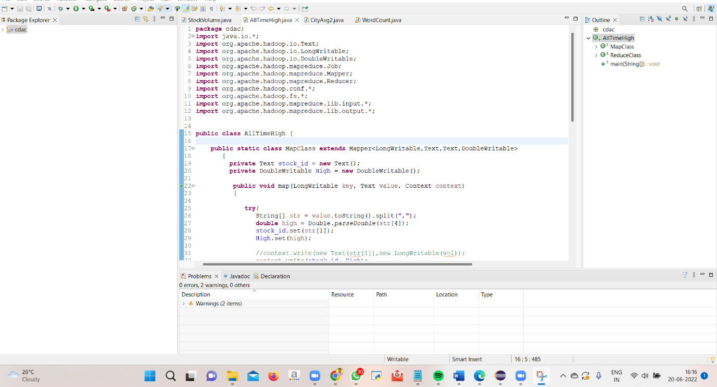

2

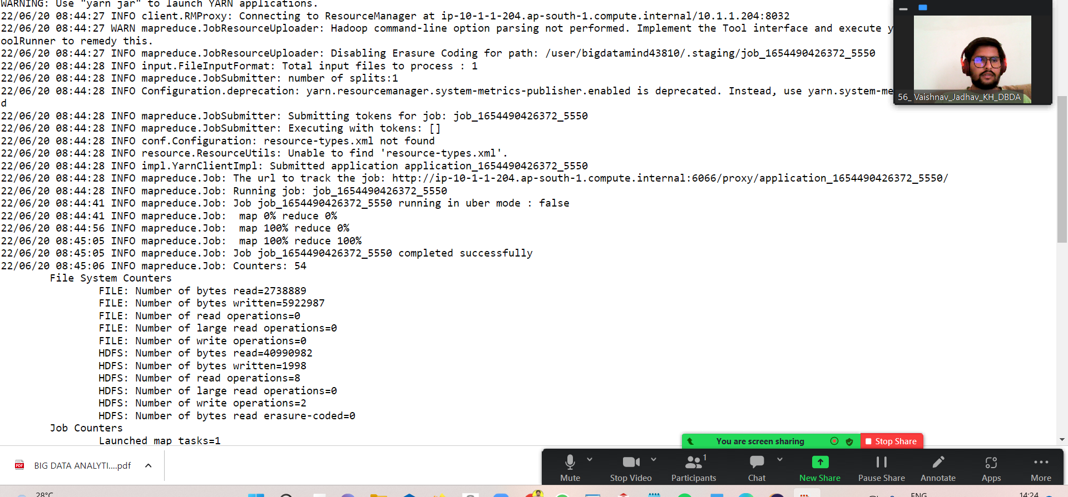

3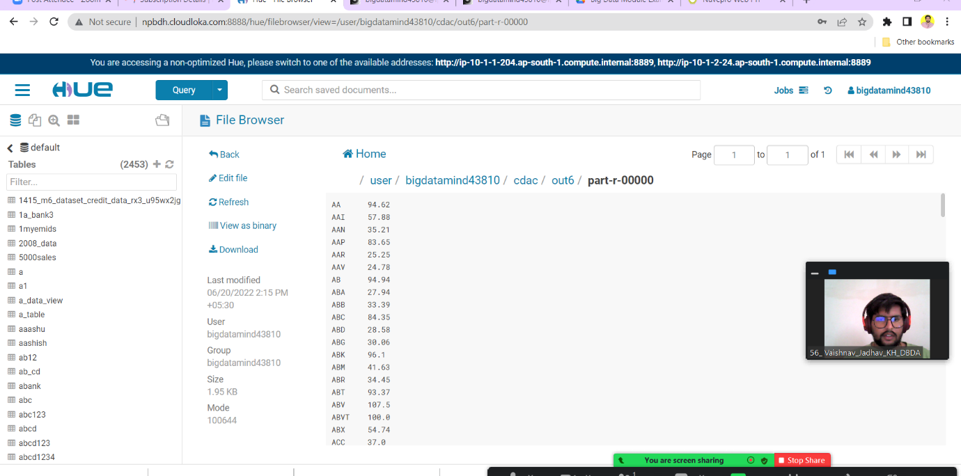

Q 2) 1) Write a program to find the count of customers for each profession. Please find the sales data set. txn id txn date cust id amount category product city state spendby 2) Write a program to find the top 10 products sales wise 3) Write a program to create partiioned table on categor

2)

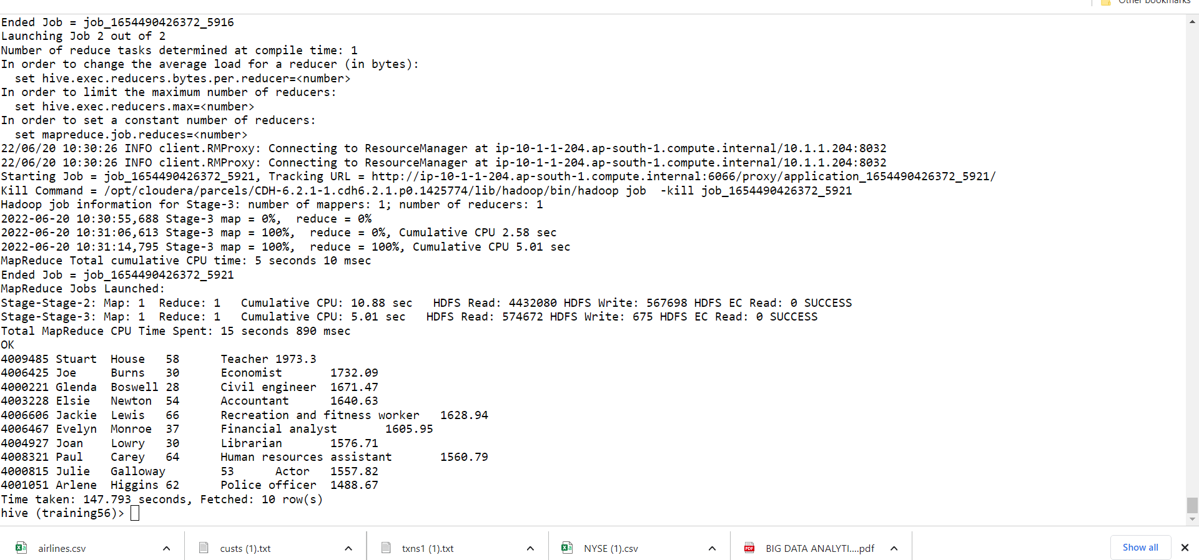

3)Write a program to create partiioned table on category

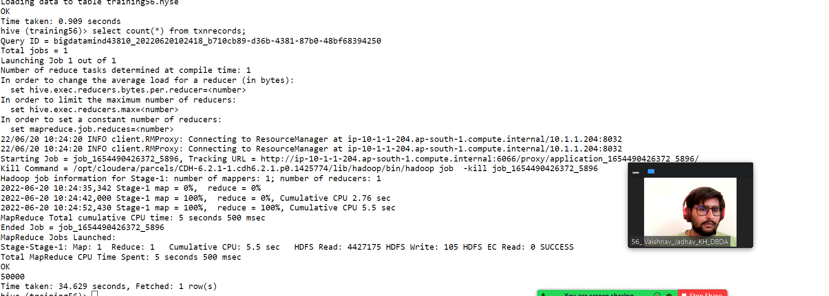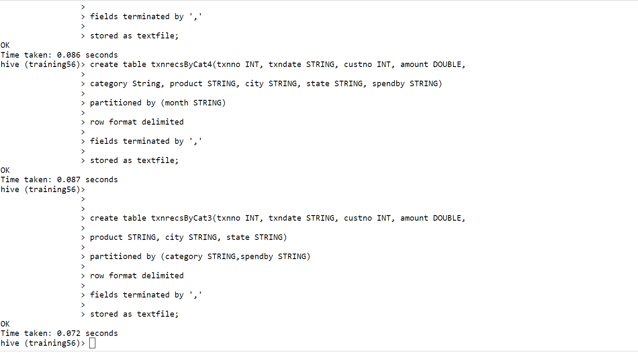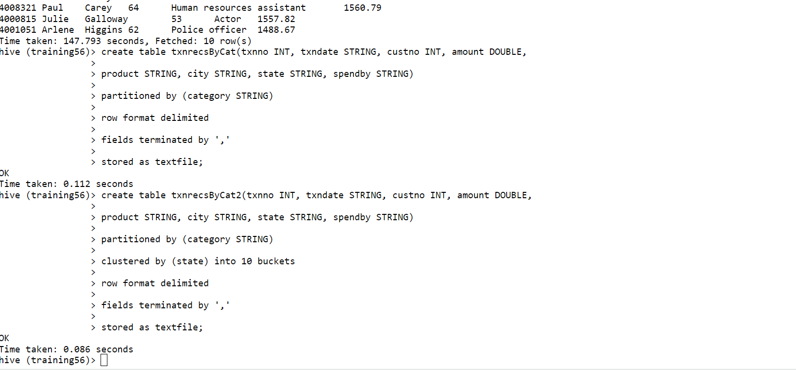

3) pyspark

